Ma ville

Unscramble each of the clue words.
Copy the letters in the numbered cells to other cells with the same number.
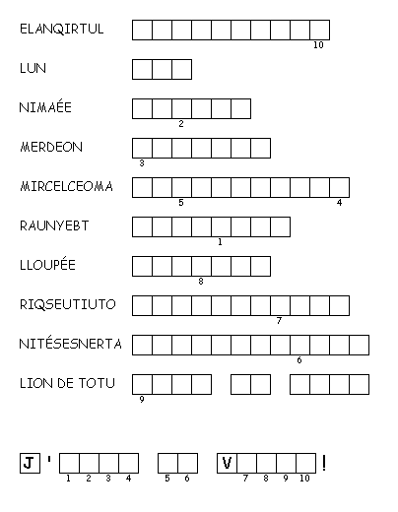

Ma ville

Unscramble each of the clue words.
Copy the letters in the numbered cells to other cells with the same number.

